Ukraine Vinnytsia School 31

Tutorial
explaining how our favorite ICT tool works

Content:
Page:
- Smart watch............................................................................. 2
- Magic Pen Recorder, digitizing handwritten text……........ 5
- Virtual reality………………………………………………. 6
- The Cronzy knob lets you choose from 16 million colors… 7
- Computer……………….…………………………………. 9
- Telephone………………...……………………………….. 11
- Graphic Tablet….…………………………………………. 12
- An interactive whiteboard……….……………………..… 14

Smart watch
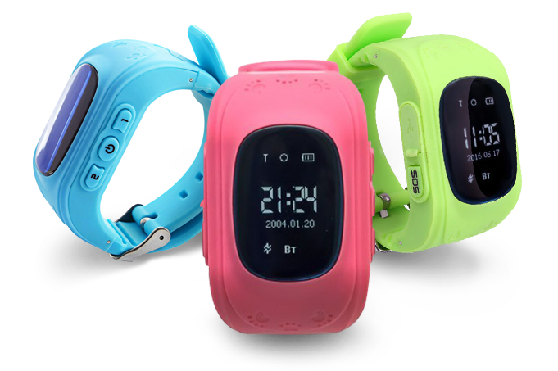
« April 24 began selling Apple Watch - smart hours, which the market had been waiting for more than two years. During these two years, on the waves of rumors about the future of Apple, a whole industry of smart clocks appeared: the most active players here were the main competitors of Apple - Samsung and Google. The South Korean company has been selling its third generation of its Gear watches, and Google has been trying to implement the Android Wear operating system for almost a year. Meanwhile, Apple Watch's release was delayed and postponed, and two announcements of this gadget (autumn and spring) caused a mixed reaction in the market: they criticized the release dates, the price, and the absence of any of the killer features. However, simple buyers did not get embarrassed: the first day, the clock bought almost a million people! This is more than Android Wear sales for 2014. »
There is a new era - portable electronics. "Intelligent" things that can be worn on themselves already surround us. Not surprisingly, the clock was also rapidly "smoother", turning into full-fledged computers with quite wide opportunities. Of course, most of the models presented in today's marketplace are, first and foremost, remote controls for smartphones. But even in this capacity it is very convenient to use them. Let's see what smart clock is capable of?
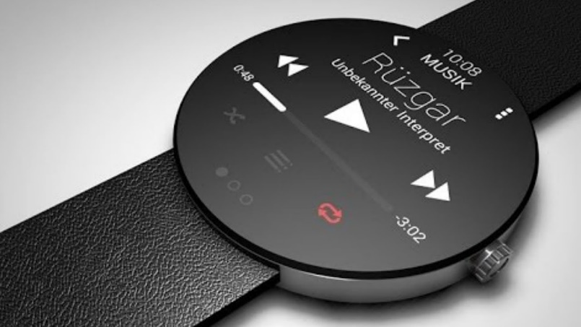
"Intelligent" watch is a gadget that, like a regular watch, is worn on the wrist. It is fastened with a strap. Without a smartphone, most "smart" hours have little to do with, maybe time to show and collect some information. But if you synchronize them with a mobile device, the situation immediately changes.

The main "chip" of all "smart" watches is the fact that their messages come from the screen of calls and text messages received on your smartphone, news from social networks, as well as reminders of scheduled events, weather forecasts, etc. d.
This is very convenient, especially in a situation where you do not want to get a smartphone from your pocket. Suppose you go down the street, hit the rain, and you forget the umbrella at home. Or ride in a busy bus. If you have smart clocks on your wrist, you can safely see who is calling, and reject a call, to read or even to listen (if the watch has such a function) came to Sesameksu, to know that tomorrow there will be no rain.
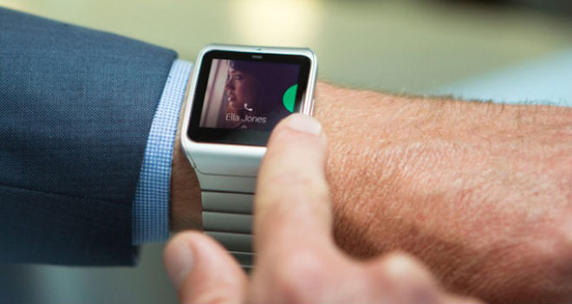
In the market you can find gadgets that understand voice commands and even allow you to make a phone call without touching a smartphone. Just raise your wrist and say in a microphone, built into a "smart" clock. Such devices are, rather, an exception to the rule, but they exist.
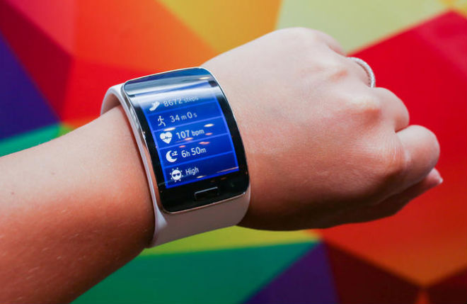
Many "smart" watches can work as fitness trackers: count the number of steps, distance traveled, speed, follow the pulse, determine the amount of calories burned, which will definitely interest people who want to lose weight. In order to get the most effective return on the smartphone, you will need to install special applications that analyze the information collected for hours.
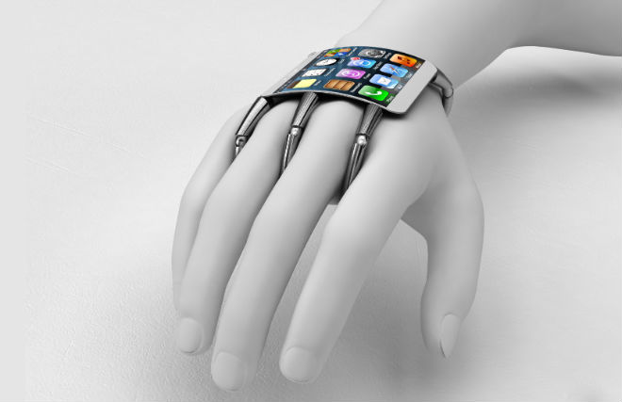
As mentioned above, there are situations when it is not desirable or impossible to remove a smartphone from your pocket. With a smart-watch on your hand, you can easily switch the song, increase or decrease volume. And there are models with the built-in player, and here they have the full right to be considered something bigger than just a remote control for the smartphone. In some models of "smart" hours there was another interesting feature - remote control of the camera. It's no secret that the removal of the Celph is, of course, fun, but not very convenient, even the specialized "sephi phoons" do not always provide the photographer with a decent level of comfort. And now you can, for example, fix a smartphone or tablet on the stand, make sure you hit the frame, and quietly press the button on the clock. What should a smart watch look like? The appearance of the device depends solely on the individual user's preferences. Most of the models are made in the form of wristwatches. You can buy a smart-watch with a deliberate bias in a sporty style, for example, the Polar M600. Often such gadgets have massive shells, large symbols and wide bracelets. At the same time, the characteristics of dust and moisture are elevated. Ribbons are often made of plastic, rubber or silicone, more rarely of metal.
Others, by contrast, simulate classical wristwatches so well that it is impossible to recognize electronic devices in them, either from the first one or from the twenty first glance. Here you can recall analogous smart hours Runtastic.
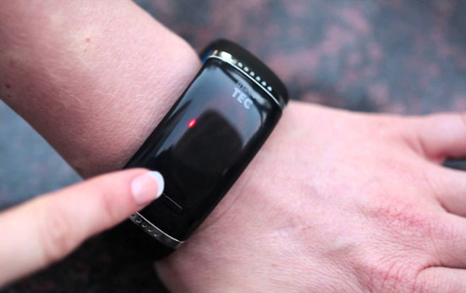
Outwardly - it's a standard clock with arrows, but when combined with a branded application, the gadget can be configured to receive messages, as well as view activity statistics by steps, number of calories, distance. Analogue, or hybrid smart watches, are so-called "smart clock with arrows". Externally - it's classic dials, and all smart features are already in the application. Messages on such a clock come in the form of a vibration or diode signal. The niche has become very popular with the launch of the Fossil brand, which has released an analog smart model for almost every brand in its portfolio.
However, the truly hybrid model of smart hours is one and belongs to MyKronoz: ZeTime watches can really work both analog and digital, and the arrows are literally cut in the center of the display, which will receive digital messages!
Intelligent watches vary in size and shape of displays. Some models have a traditional look of the dial and a special screen for displaying messages. Sometimes this function is performed by one or more LEDs. In other models, the dial entirely takes a display that can be arranged in any style. The collection of styles is most often represented by dials in the traditional dial format or digital worksheets. When thinking about which smart watch to choose, it's worth remembering that they are worn on the wrist, so the extra-large body will be uncomfortable in daily operation. The universal size is 1.4-1.7 inches.
Magic Pen Recorder, digitizing handwritten text
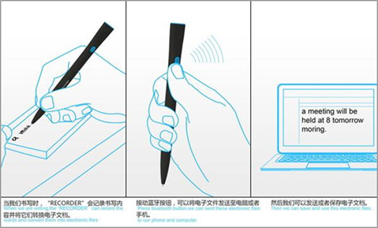
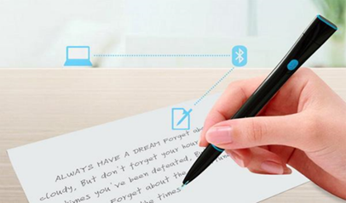
A blank sheet and a pen, curves lines ... Today, many people refuse to write handwritten text in favor of newfangled computers and smartphones. But the concept of Handles Recorder promises to radically change the position. The fact is that the wonder-handle can digitize the written text and send it via Bluetooth to any gadget.
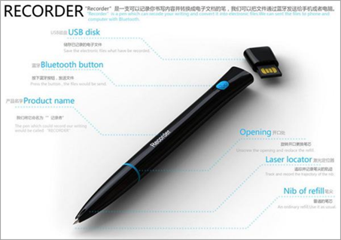
Chinese designers who created the pen Recorder decided to combine the past with the present. The time when everyone wrote manually and the era of digital media. The new concept records the trajectory of the pen with a laser sensor, and then displays the data on the screen of a mobile phone or computer. The transfer of information is via Bluetooth or a flash drive located at the end of the product.
Files with digitized text can be sent via Bluetooth or a built-in USB flash drive
For writing, the pen uses ordinary ink. The cartridge can be filled as needed. While the three main colors of ink are provided: blue, black and red, but designers promise to expand the range in case of successful sales of the gadget.
Virtual reality
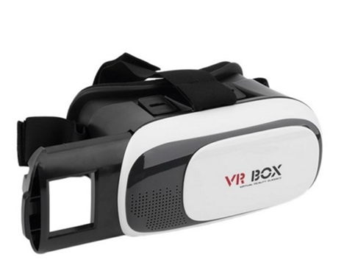
Virtual reality (BP, English virtual reality, VR, artificial reality) is a world created by technical means, transmitted to a person through his senses: sight, hearing, smell, touch, and others. Virtual reality simulates both exposure and reaction to impact. To create a convincing set of sensations of reality, computer synthesis of the properties and reactions of virtual reality is made in real time.
The objects of virtual reality usually behave closely to the behavior of similar objects of material reality. The user can operate on these objects in accordance with the actual laws of physics (gravity, water properties, collision with objects, reflection, etc.). However, often for entertainment purposes, users of the virtual worlds are allowed more than possible in real life (for example: fly, create any objects, etc.).
Do not confuse the virtual reality with the supplemented. Their fundamental difference is that the virtual constructs a new artificial world, and the augmented reality only introduces separate artificial elements into the perception of the real world.
Specially equipped simulators and a certain kind of slot machines add other sensations to the image and sound of the computer game / simulator, such as motorcycle inclination or shaking of the car seat. Such professional simulators with appropriate real-world controls are used to train pilots. Virtual reality is used to train professions, where the operation of real devices and mechanisms is associated with increased risk or is associated with high costs (aircraft pilot, train driver, dispatcher, driver, mining rescuer, etc.).
The Cronzy knob lets you choose from 16 million colors
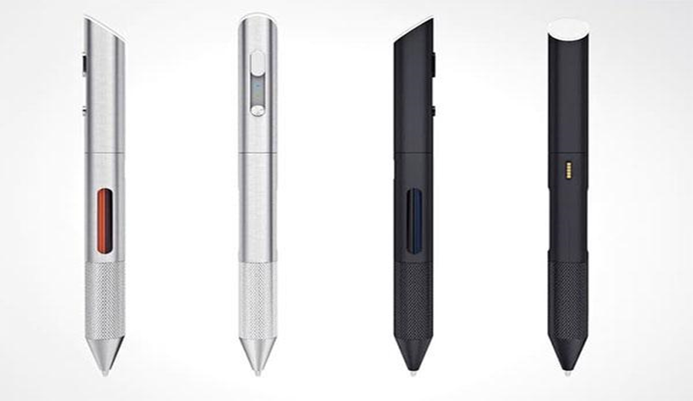
When we were studying at elementary school, a ballpoint pen with four colors seemed to us the peak of steepness. Red, blue, black and green in one case? Magic! Then there were ten colored pens. Now, Cronzy Inc. from Los Angeles is planning to finally confuse us, introducing a pen with a palette of 16 million colors.
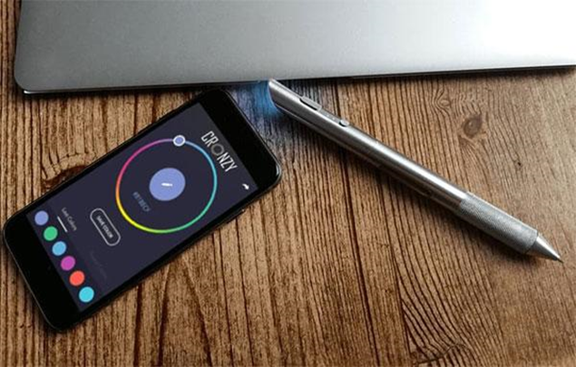
Okay, they're not the first. In 2014, Kickstarter launched a campaign to raise funds for the production of pens from more than 100,000 different colors. It was a pen from Scribble's startup, with it somehow did not happen and the campaign was rolled over. On the startup site, it still hangs out how available for pre-order, however, no data on the expected date of delivery is available.
Despite the fact that the Cronzy handle essentially does the same thing as Scribble goes out, it can just see the light at the end of the tunnel. In order to choose the most appropriate color, it is enough for users to identify it using a companion application. The application palette is made in Photoshop style. The color is selected, the data is sent to the pen. You can write or draw!
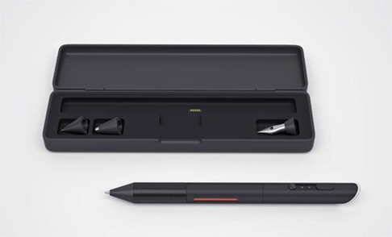
It sounds very cool. However, it is not so easy to determine the desired color with only one color ring. Here on the scene comes the built-in scanner. Instead of trying to pick up a shade, you can just wave a magic wand (ok, pen). Also, the colors you use can be memorized in-app or shared with other users with saved shades.
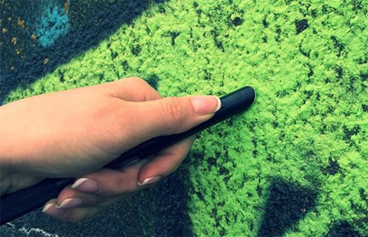
The colors are mixed right in the handle. At the moment, the team of developers is engaged in calibrating the process of mixing the ink. In order to avoid mixing the colors when drawing, it's enough to simply clear the handle by holding a couple of lines. When the ink dries, it can be replaced quickly. A new ink of one color will cost about $ 2. It will be enough to hold a 500-meter-long line without mixing. In general, the cost of ink will vary, white may cost the users much more.
Now the developers of the hand collect funds for its production through Indiegogo. After investing $ 139, you will get Cronzy itself, two sets of ink cartridges and a case. To be sent by pre-order is scheduled for May 2017.
Computer
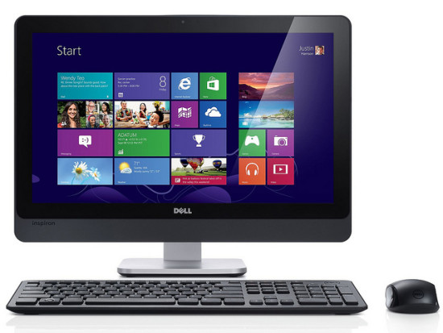
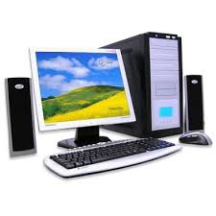
The first computers were created exclusively for computing (shown in the names "computer" and "computer"). Even the most primitive computers in this area are many times superior to people (unless you take into account the potential of some unique "people-counters"). It is no accident that the first high-level programming language was Fortran, designed exclusively for mathematical calculations. In this sphere of application of computers began the database. First and foremost, they were needed by governments and banks that require more sophisticated computers with advanced I / O systems and information storage. For these purposes, the Kobol language was developed. Later, there were DBMS with their own programming languages. The third application was the management of a variety of devices. Here the development proceeded from highly specialized devices (often analogues) to the gradual introduction of standard computer systems, which run control programs. In addition, more and more of the technology begins to include a control computer. Computers have evolved to such an extent that they have become the main informational tool both in the office and at home. Now, almost all work with information is often carried out through a computer - a set of text or movie viewing. This applies both to the storage of information and to its transmission by communication channels. The basic use of modern home computers is web navigation and games. Modern supercomputers are used for computer simulation of complex physical, biological, meteorological and other processes, and to solve applied problems, such as modeling of nuclear reactions or climate change. Some projects are carried out using distributed computing, when a large number of relatively weak computers simultaneously work on small parts of the overall task, thus forming a very powerful computer system. The most complex and less developed area of ​​computer use is artificial intelligence - the use of computers to solve such problems, where there is no clearly defined more or less simple algorithm. Examples of such tasks are games, machine translation of the text, expert systems.
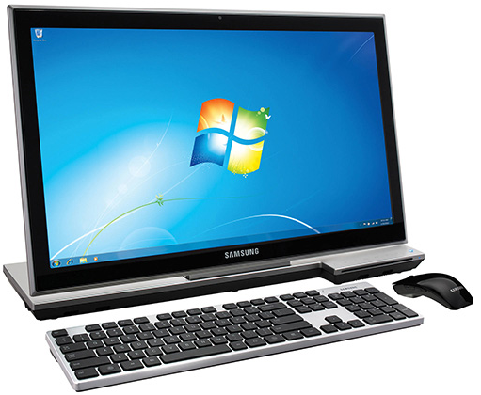
The modern personal computer has ten times more power than its time was required to run and put the person on the moon. The volume of the CD is enough for 72 minutes of music sound. This is the very duration of the ninth Beethoven symphony, which was based on the creators of the new product. We have a fraction of a second to evaluate the quality of the site we are visiting. Chinese gamers are not allowed to play games that promote murder - for example, in "GTA" or "Postal". They are not honored in the Middle Kingdom and hackers: they are faced with serious prison terms, and in 1998 a couple of crackers were even sentenced to a higher degree of punishment. Hackers, of course, should not be protected - criminals of the information space. But also do not forget about your loved ones. Some accounts, email addresses and other personal pages of the internet space are being asked to break them! The most popular passwords are digits in ascending or descending order, as well as the date, month, and year of birth. Many users are so carefree that they even enter in the windows "login" and "password" the same set of characters. If you often sit at your computer for a long time, then blink at least seven times a minute. So our eyes are trying to prevent the syndrome of "office vision". Millions of letters arrive daily on the official Bill Gates e-mail. Is it necessary to say that the overwhelming majority of them remain unanswered? Whether or not the computer can fit and overtake us for ability, there is a lot of controversy. But the "man of the year" has already been recognized by him: in 1982, the workers of the magazine "Chas" made it. People who are afraid of computers and all that is associated with them, are called cyber-robots. Two thirds of Americans have been staying on the Internet for at least three hours a day. We think our compatriots are not much less ...
Telephone
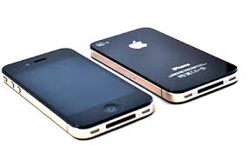
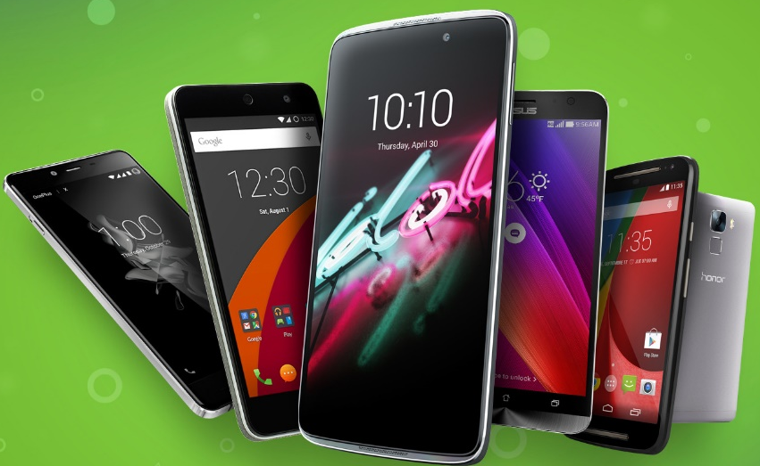
The phone is a type of telecommunication that allows you to transmit and receive broadcasting at a distance by means of electrical signals (transmitted by wires) or radio signals.
The term "smartphone" was first introduced by Ericsson in 2000 to advertise the new Ericsson R380s phone. The device was running Symbian OS v5.1 and had a monochrome touch screen under the hinged lid. The performance of any modern smartphone, including yours, exceeds the total power of all computers used by NASA to calculate and manage the landing of man to the moon within the Apollo program. In Japan, 90% of the phones are released in the body that protects against moisture, because the Japanese youth do not part with them, even in the bathroom and under the shower. The fear of losing your cell phone or getting rid of communication is called a nomophobia. This term appeared in 2010 in a study devoted to the habits of mobile users. Approximately half of the respondents admitted that they are worried when they lose their mobile phone, it ends up charging the battery or money in the account or it is out of reach. The most successful phone in the world is the Nokia 1101. Since its inception in 2003, more than 250 million devices have been sold, a record not only among mobiles, but also among electronic gadgets in general. Now the model is discontinued. According to the UN report published in 2013, the number of owners of mobile phones is significantly higher than the number of people having a toilet. Six out of seven billion people have cell phones, but only 4.5 billion live in decent sanitary conditions. Thinking of mobile phones is a popular sport in Finland, Belgium and some other countries. The world championship in this discipline, which took place in 2014, set a new world record - 110.42 meters.
Graphic Tablet
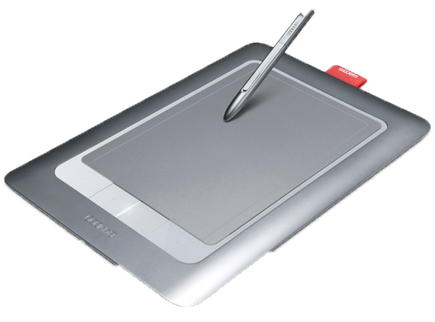
Graphic Tablet is a device for inputting pictures manually directly to a computer. It consists of a feather and flat plate, sensitive to pressing or proximity of the pen.
In the first plates, the pen, touching the surface, produced a spark, the sound of which was captured by the microphones located nearby. The triangulation method determined the position of the pen in space. Such a system was complicated, expensive and at the same time unreliable, since external noise prevented accurately determine the position of the pen.
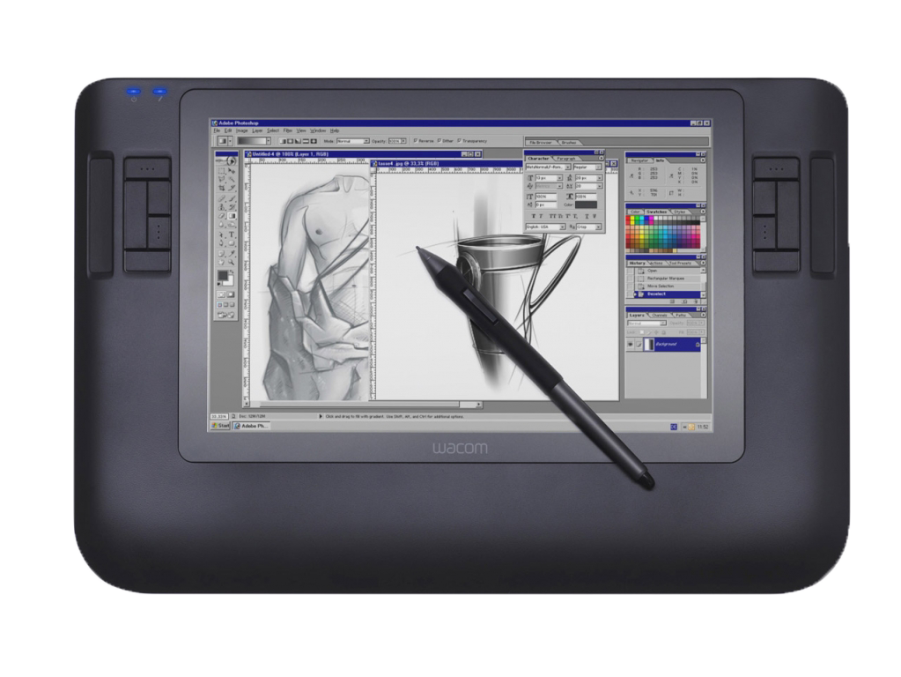
The first graphic tablets, similar to modern ones, were presented in 1964 under the name "Grafacon". They contained a grid of thin wires that created a sequence of weak magnetic impulses that could be captured by a pen. This allowed to determine the current position of the pen.
The first tablets for the consumer market were called "Koala Ped". Although initially they were created for the Apple II computer, Koala subsequently spread to other personal computers. Then other companies began to release their tablet models.
In modern tablets, the main working part is also a network of wires (or printed guides), similar to the one that was in the "Graphicons." This grid has a fairly large step (3-6 mm), but the pen registration mechanism allows the step of reading information much less than the grid step (up to 100 lines per mm).
On the principle of work and technology there are different types of tablets. In electrostatic tablets, a local change in the electrical potential of the net under the pen is recorded. Electromagnetic waves emanate in the electromagnetic pen, and the grid serves as a receiver. In both cases, the power should be fed to the pen.
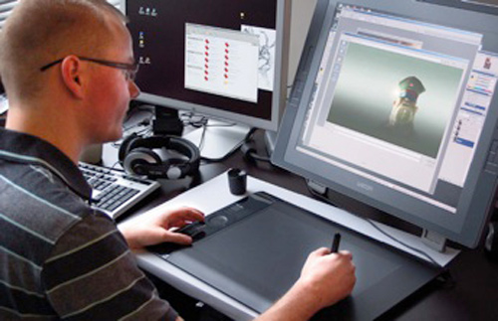
Wacom has created a technology based on electromagnetic resonance when the grid emits and receives the signal, and the pen only reflects it. Therefore, it is not necessary to feed a pen in such a device. But when working on electromagnetic plates, interference from emitting devices, in particular monitors, is possible.
There are also tablets in which the pressure of the pen is captured by the piezoelectric effect. When the pen is pressed within the working surface of the tablet, under which a grid of finest conductors is laid, a potential difference arises on the piezoelectric plate, which allows determining the coordinates of the desired point. Such tablets do not require a special pen at all and allow you to draw on the working surface of the tablet as on a conventional drawing board.
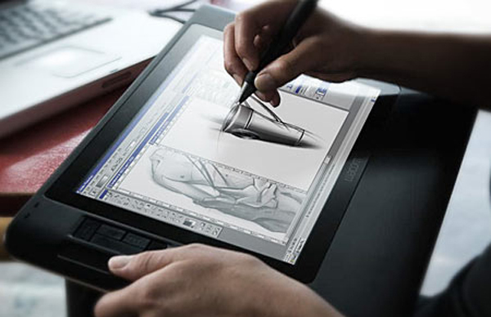
In addition to the coordinates of the pen in modern graphic tablets can also be determined by the pressure of the pen on the work surface, the slope, direction and force of compression of the pen by hand.
Also included in the graphic tablet in conjunction with the pen can be supplied with a mouse, which, however, does not work as a normal computer mouse, but as a special type of pen. Such a mouse can work only on the tablet. Since the tablet resolution is much higher than that of an ordinary computer mouse, the use of the mouse + tablet interface allows you to achieve significantly higher precision when typed.
Graphic Tablets are used to create images on a computer in a manner that is as close as possible to how images are created on paper, and for the normal work with interfaces, which does not require relative input.
An interactive whiteboard
An interactive whiteboard - a device that combines the capabilities of a conventional marker board with the capabilities of the computer.
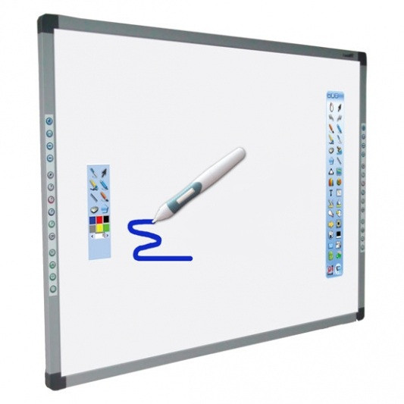
Together with the multimedia projector, it becomes a large interactive screen, with the touch of a hand to the surface of which you can open a computer application or web resource and display the desired information or draw. Drawn or written may be saved as computer files, printed, sent by e-mail, even saved as web pages and placed on the Internet. While working with an interactive whiteboard, the student learns not only through audio and visual channels of perception, but also through a kinestetic that is almost not used in modern pedagogy. Therefore, children who have not received information through this channel - are potential "triochnikami". This situation can be corrected precisely by interactive technologies - each student intuitively chooses the most convenient way of perception of information when working with an interactive whiteboard.
The most popular interactive whiteboards have been acquired in secondary schools.
An interactive whiteboard is a peripheral device of the computer and serves as an additional computer monitor. The interactive whiteboard is different from a regular monitor with a touch sensitive surface that is large in size - for ease of use with the audience.
Like an ordinary computer monitor, the computer application control software is implemented either with the mouse cursor, or with an on-screen keyboard that is pushed to the surface of the board. The role of the mouse cursor on this secondary monitor with the touch surface performs any solid object, such as a finger, a marker or marker. Boards differ in price, dimensions, weight, materials and technology used to read the coordinates of the mouse cursor from the touch surface of the board.
The interactive whiteboard is designed to be used in conjunction with a computer and a multimedia projector and is a software program or technical and technological training complex.
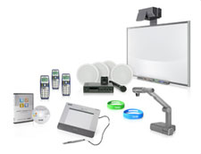
Such complexes, mainly, differ from each other not the volumetric and technical characteristics of interactive whiteboards, projectors and computers, and the capabilities of the software interactive whiteboard included with them.
Currently, there are 11 major interactive whiteboard manufacturers in the world.
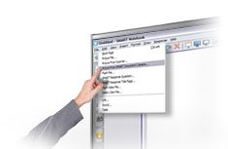
The first and undisputed leader among them is SMART Technologies Inc., which together with its shareholder and strategic partner, Intel has created a qualitatively different software and technology product - the SMART Board Interactive White Board, which became the main component of software and technology training complexes.
Such complexes since 2000 have become the basic tool of ICT in educational systems of 150 countries of the world, in particular in the USA and the countries participating in the Bologna Agreement.

