“Electric City” – Our Class Innovation Project

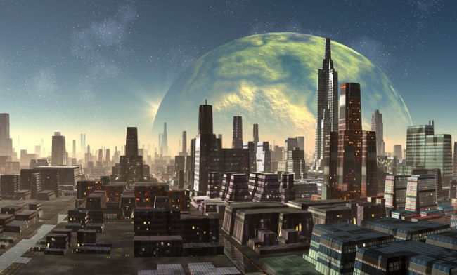
You have been ‘contracted out’ by the city council to develop our city (Electric City of 6G). As the planners and builders, the people want you to DESIGN and BUILD a city that will be sustainable (use renewable energy) AND help the people in some social cause.

TASK: In pairs, you are going to design a model of one essential part of a city/town/village. This model should meet the following requirements:

Use both series and parallel circuits to perform a function such as
- lighting up LED lights on a building, moving an object on the ground, spinning a windmill, etc.

Be a realistic 3D structure that represents part of a city in real life
- that is coloured and ‘clean – cut’ with exact measurements (i.e. the houses look identical, the wind farm has the same windmills, a river looks like a river, etc.)

Cannot be larger than the area of ‘land’ given to you and must use the materials
you are given (along with your own materials from home)
- Some of the materials will be supplied to you (i.e., the LED lights, some of the copper wiring, paperclips and fasteners for switches), but YOU will need to bring in some from home too

Needs to connect to a renewable energy source in our city
- So, your actual work will use electricity and wires for us to see…but you must show how the MODEL is connected to one of the power sources
- 2-3 pairs will be responsible for designing these energy generators – solar, wind, hydro

It has to HELP some social problem in our world (i.e., poverty, environment, healthcare, education, women’s rights, etc.)
- You are free to decide how it will help (i.e., it could be a building, something moving, an area of new community houses for the homeless, solar powered-offices, etc.)
- This is where you can connect your work to the of the UN Sustainable Development Goals

